HealthConnect Final Analytics Package
HealthConnect Clinic — Data Analytics Track, Final Integration & Presentation
AnalystLab Africa Experience Lab — Week 8
Prepared by Oluwatosin Olusanya, Data Analyst — AnalystLab Africa

Executive Summary
HealthConnect Clinic loses over half of its scheduled appointment capacity to no-shows — a 51.2% rate confirmed, independently re-validated, and statistically tested across an 8-week analysis. Two factors drive this overwhelmingly: how far in advance a patient books (26.6% no-show at 0-3 days vs. 63.9% at 30+ days, χ²=340.42, p<0.001) and a patient's own no-show history (46.3% vs. 70.3% for 3+ prior no-shows, χ²=72.36, p<0.001). Combined into a single risk matrix, these two factors identify a clear, appropriately sized highest-risk group — 1,529 appointments (1,035 patients) at 63.6% no-show — that the clinic can target directly. Reminders help, but only modestly, and mainly for at-risk patients; they are not a standalone fix. Every finding in this package has been independently reproduced from the raw dataset, tested across demographic segments, and stress-tested against a key methodological decision — this is not a first-pass analysis but a validated, portfolio-ready decision-support package.

1. Final Validated KPIs
KPI | Final Value | Notes
Overall No-Show Rate | 51.2% | 2,423 of 4,737 definitive-outcome appointments; reproduced exactly in Week 7
No-Show Rate by Lead Time | 26.6% → 63.9% | 0-3 day vs 30+ day booking window; χ²=340.42, p<0.001
Repeat No-Show Rate | 46.3% → 70.3% | 0 vs 3+ prior no-shows; χ²=72.36, p<0.001
Reminder Effectiveness | 0.4 – 6.5pt | Improvement varies by risk segment; largest for at-risk patients
Combined Risk Segmentation | 28.0% → 63.6% | Lowest-risk (715 appts) vs highest-risk (1,529 appts) combined segment

2. Key Visualizations
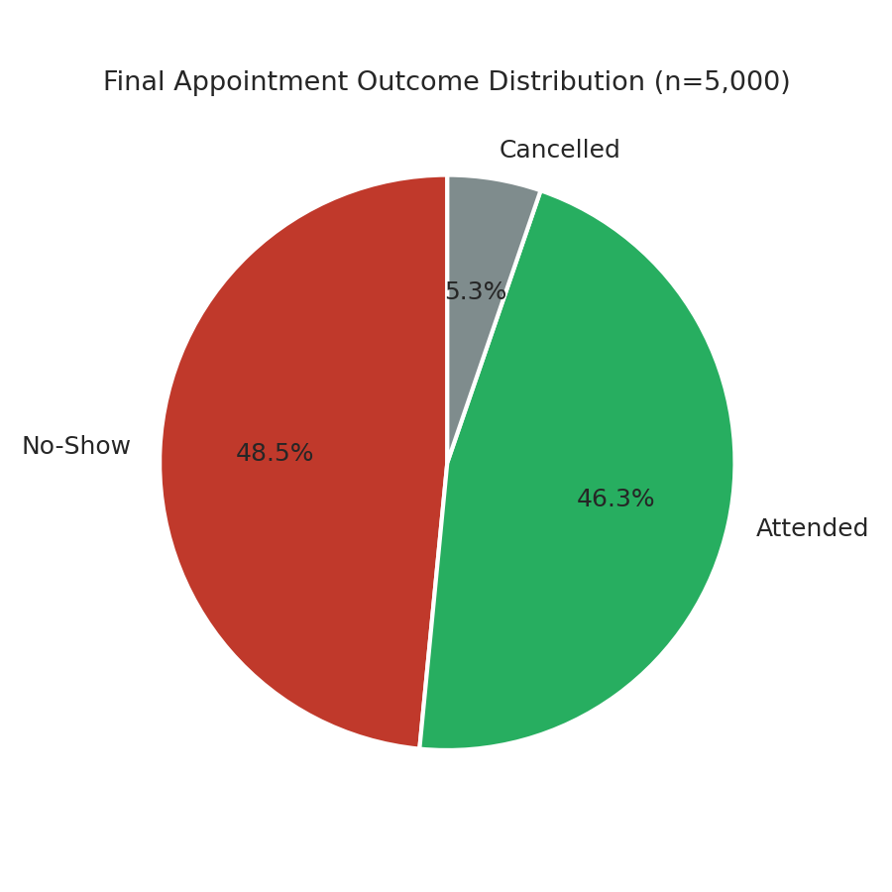
Figure 1: Final appointment outcome distribution across all 5,000 appointments.
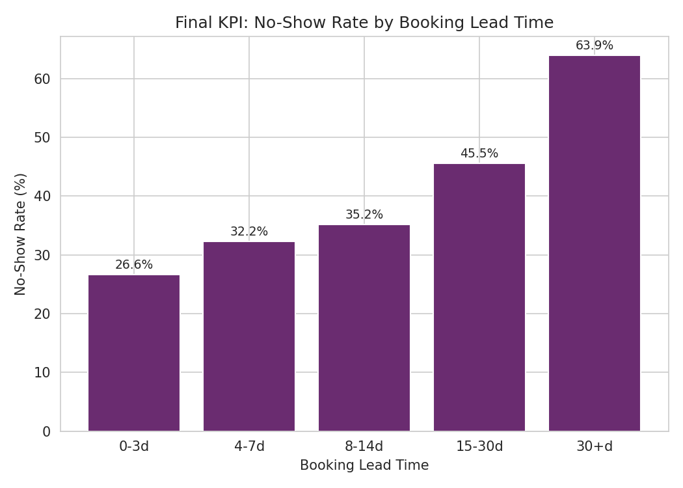
Figure 2: No-show rate by booking lead time — the strongest individual driver.
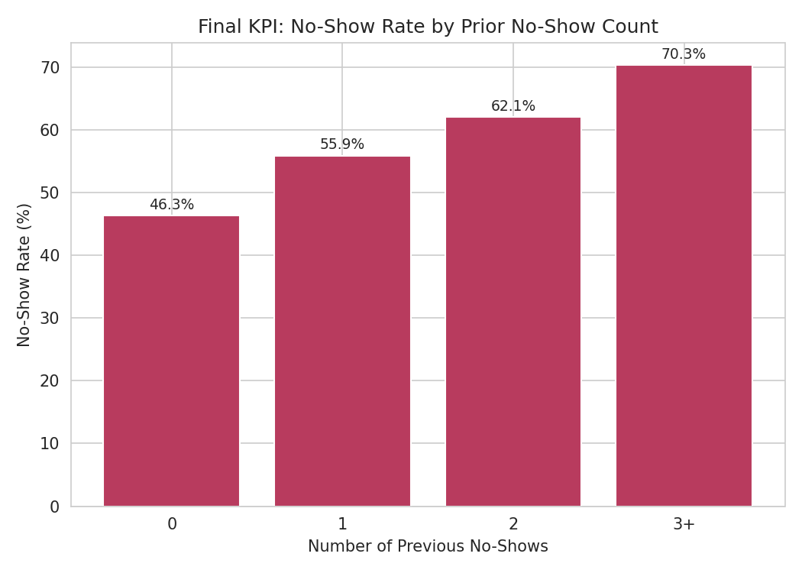
Figure 3: No-show rate by prior no-show count — the second-strongest driver.
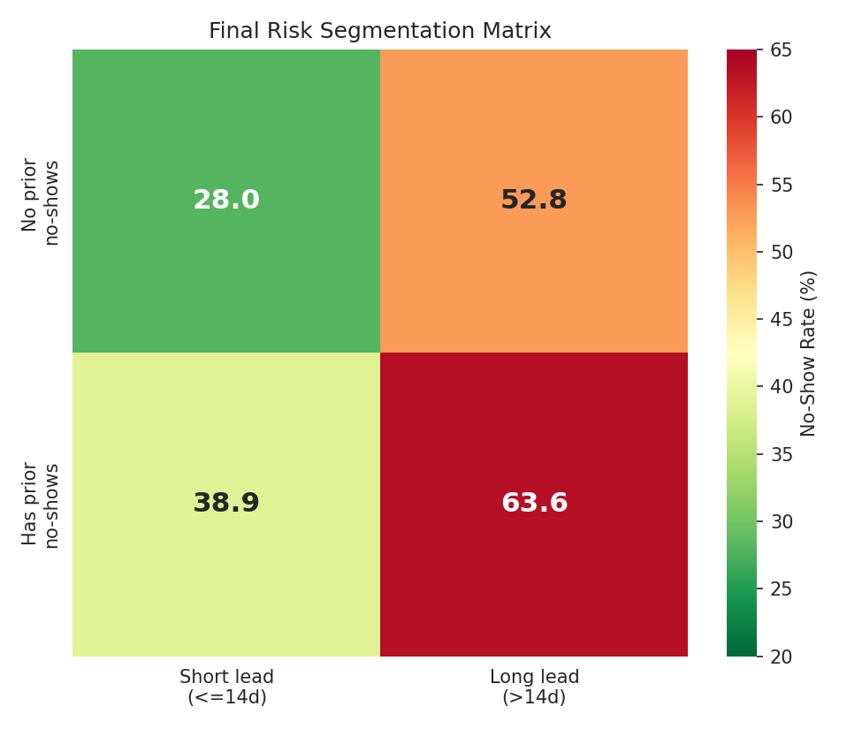
Figure 4: Final combined risk segmentation matrix.
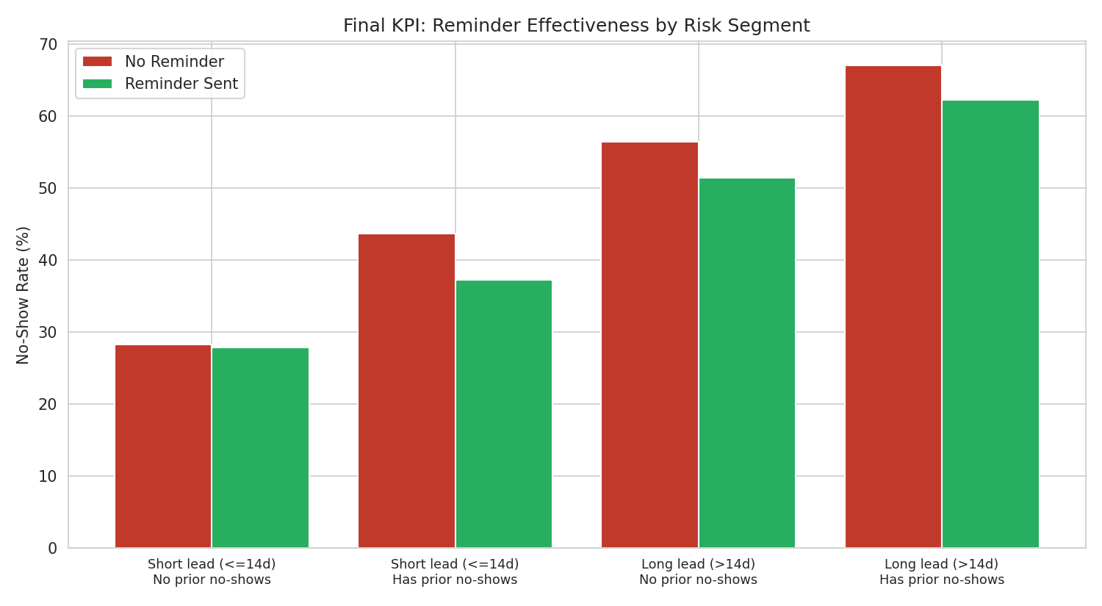
Figure 5: Reminder effectiveness by risk segment — largest effect where it's needed most.
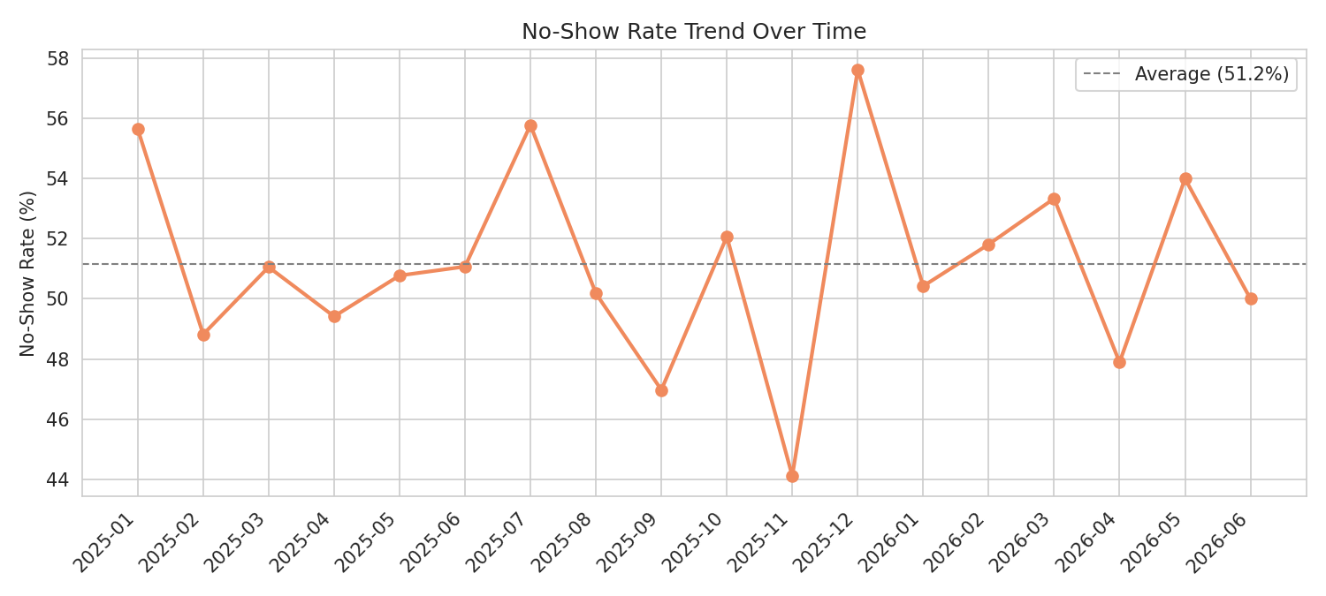
Figure 6: No-show rate trend over time — stable, not seasonal, confirming this is a structural issue.

3. Validated Findings
- The 51.2% overall no-show rate, both chi-square tests, and all five core KPIs were independently re-derived from the raw dataset in Week 7 and reproduced exactly — the analytical pipeline has zero calculation errors.
- Booking lead time and prior no-show history combine additively, not synergistically (interaction test p=0.50) — each factor can be addressed independently without needing a special combined-risk protocol.
- The lead-time effect holds across gender and every age group, though it is measurably weaker for patients under 25 and over 65 than for working-age patients.
- The headline findings are robust to how "Cancelled" appointments are treated — rates shift 2-5 points under an alternative treatment, but the underlying pattern is unchanged.
- A claim from an early external-tool-assisted draft — that reminders were disproportionately sent to lower-risk patients — was tested directly and found false; reminder-send rates are nearly identical (71.6-74.3%) across all risk segments. This was documented as a failed test rather than silently dropped, reflecting the rigor applied throughout this package.

4. Business Insights
- Roughly one in two scheduled appointments is missed — a severe, structural operational problem, not a seasonal or occasional one.
- A single, appropriately sized group of 1,529 appointments (1,035 patients) accounts for a disproportionate share of no-show risk and is directly targetable with the combined risk matrix.
- Reminders are a reasonable low-cost baseline but cannot solve this alone — their effect is real but modest, and smallest exactly where risk is already low.
- Younger (18-24) and older (65+) patients need a different intervention than the core working-age population, since the primary lead-time lever is measurably less effective for them.

5. Business Recommendations
- Deploy the combined risk matrix operationally: route the 1,529-appointment highest-risk segment to manual confirmation calls or double-booking policies, rather than treating all patients identically.
- Introduce a shorter default booking window, or a mandatory re-confirmation step, for any appointment booked more than 14 days in advance.
- Design a distinct outreach approach for patients under 25 and over 65 (e.g. caregiver-coordinated contact for older patients, different channel/cadence for younger patients).
- Maintain reminders as a baseline intervention, prioritizing SMS (the best-performing channel identified in Week 5), but do not rely on them as the primary fix.
- Adopt this validated risk-segmentation approach as a standing quarterly review, given the no-show rate has remained structurally stable (not seasonal) across the full analysis period.

6. Limitations
- This is a descriptive/associational analysis; it identifies strong, statistically validated, and segment-stable patterns, but does not by itself prove that intervening on lead time will causally reduce no-shows by a proportional amount.
- Small amounts of missing data in distance_to_clinic_km (1.8%) and waiting_time_minutes (1.2%) were excluded row-wise from the specific calculations using those fields.
- The "Cancelled" outcome was excluded from headline no-show rate calculations; this decision was explicitly tested for sensitivity (Week 7) and found not to materially change the conclusions, but remains a methodological choice worth revisiting if the clinic's operational definition of "non-attendance" differs.
- No interactive BI dashboard was built for this project; all visual outputs are static, reproducible charts generated directly from the validated dataset.
- Age-band segment findings are based on moderate sample sizes once split by lead-time band; the direction of the finding is clear but exact magnitudes should be treated as indicative.

7. Cross-Track Integration (HC-POD)
Collaboration with Project Management
Dependency: PM's Week 7-8 readiness and resourcing planning needed a concrete, sized target population rather than an abstract statistical pattern.
Outputs exchanged: the Week 7 combined risk matrix (1,529-appointment / 1,035-patient highest-risk segment) and the explicit confirmation that no reminder-assignment bias exists in the current process.
Final integration activity: this validated segment size was incorporated into PM's Week 7 testing/refinement priorities and is being carried into Week 8 final planning as the concrete basis for scoping a targeted confirmation-call intervention.
How this improved the final solution: replaced a vague "target high-risk patients" goal with an operationally sized, evidence-backed group PM can actually plan staffing and workflow around.

8. HC-POD Walkthrough Notes
This Data Analytics track's contribution sits at the foundation of the HealthConnect solution: the business problem (missed appointments) was translated into a clean, validated dataset understanding (Week 4), calculated KPIs and initial insights (Week 5), statistically validated and refined drivers (Week 6), independently re-tested and stress-tested findings (Week 7), and finally a portfolio-ready decision-support package (Week 8). This work directly feeds the Project Management track's resourcing plan, via a sized, targetable risk segment — demonstrating how rigorous, testable analytics underpins the rest of the HealthConnect solution rather than standing apart from it.

